# Data Analysis For the Smart Nutritional Planner

Biplab Bijoy Mahato

**Data Information:**

Collected from <https://www.kaggle.com/datasets/thedevastator/healthy-diet-recipes-a-comprehensive-dataset>

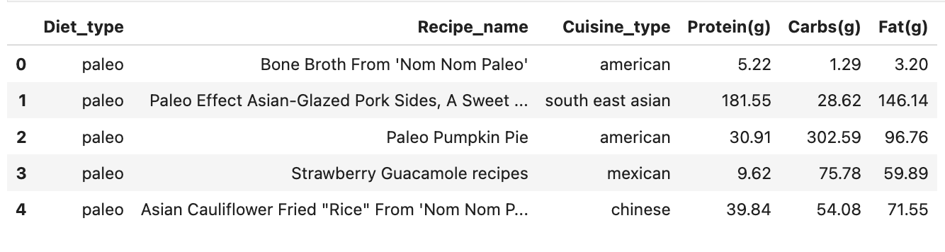

**Visualization for flowcharts for methodology**

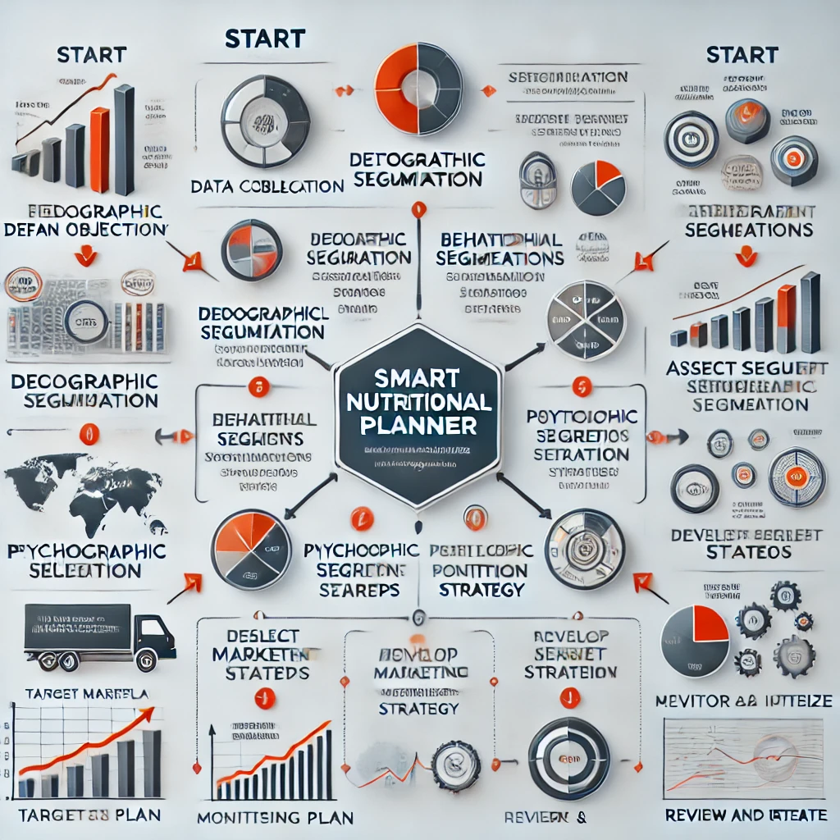

Market/Customer/Business Need Assessment:

**1.Growing Health Consciousness**:

* + The increasing awareness of health and wellness has led to a rise in demand for specialized diets such as Paleo, Keto, Vegan, Mediterranean, and Dash.

2.**Nutritional Information Transparency**:

* Customers want clear and detailed nutritional information to make informed choices about their diet. The dataset provides macronutrient details (protein, carbs, fats), which can help customers select recipes that align with their dietary needs and goals.

3.**Variety and Taste**:

* Consumers do not want to sacrifice taste for health. There is a need for diverse and flavourful recipes that cater to different dietary preferences while ensuring nutritional benefits. The data highlights a wide range of cuisines (American, South East Asian, Mexican, Chinese), offering plenty of options to satisfy varied taste preferences.

4.**Targeted Marketing**:

* Understanding the dietary preferences and nutritional needs of different customer segments allows businesses to create targeted marketing campaigns. Highlighting specific benefits, such as high-protein recipes for muscle gain or low-carb options for weight management, can attract and retain customers.

5.**Partnership and Collaboration**:

* Businesses can collaborate with nutritionists, dietitians, and fitness experts to create and promote diet-specific meal plans and products. This can enhance credibility and trust among health-conscious consumers.

Target Specifications and Characterization:

**High-Protein Recipes**

* **Characterization**: Recipes with a focus on muscle gain and satiety, such as "Turkey Soup" and "Homemade Turkey Alphabet Soup," characterized by high protein content (30-50g per serving), moderate to low carbs, and varying fat levels based on diet type.
* **Target Audience**: Athletes, bodybuilders, and individuals looking to increase muscle mass or maintain a high-protein diet for satiety and weight management.

**High-Carbohydrate Recipes**

* **Characterization**: Energy-boosting recipes like "Strawberry Kiwi Daiquiri Cupcakes" and "Baked Banana Chip Encrusted French Toast," with high carbohydrate content (100-200g per serving), moderate protein, and varying fat levels.
* **Target Audience**: Individuals needing quick energy boosts, such as athletes, active professionals, and those with high-energy demands.

**Low-Carb Recipes**

* **Characterization**: Recipes designed for weight loss and blood sugar management, such as "Low Carb Beef and Cheddar Cauliflower Bake," characterized by low carbohydrate content (under 20g per serving), high protein, and high fat content.
* **Target Audience**: People following Keto or low-carb diets for weight loss, diabetes management, or overall health improvement.

**Balanced Nutrient Recipes**

* **Characterization**: Well-rounded recipes like "Orange and Five-Spice Roasted Chicken Legs" that offer a balance of macronutrients (protein, carbs, fats) and are rich in micronutrients.
* **Target Audience**: General population seeking a balanced diet for overall health and wellness, including families and individuals without specific dietary restrictions.

Word Cloud Analysis:

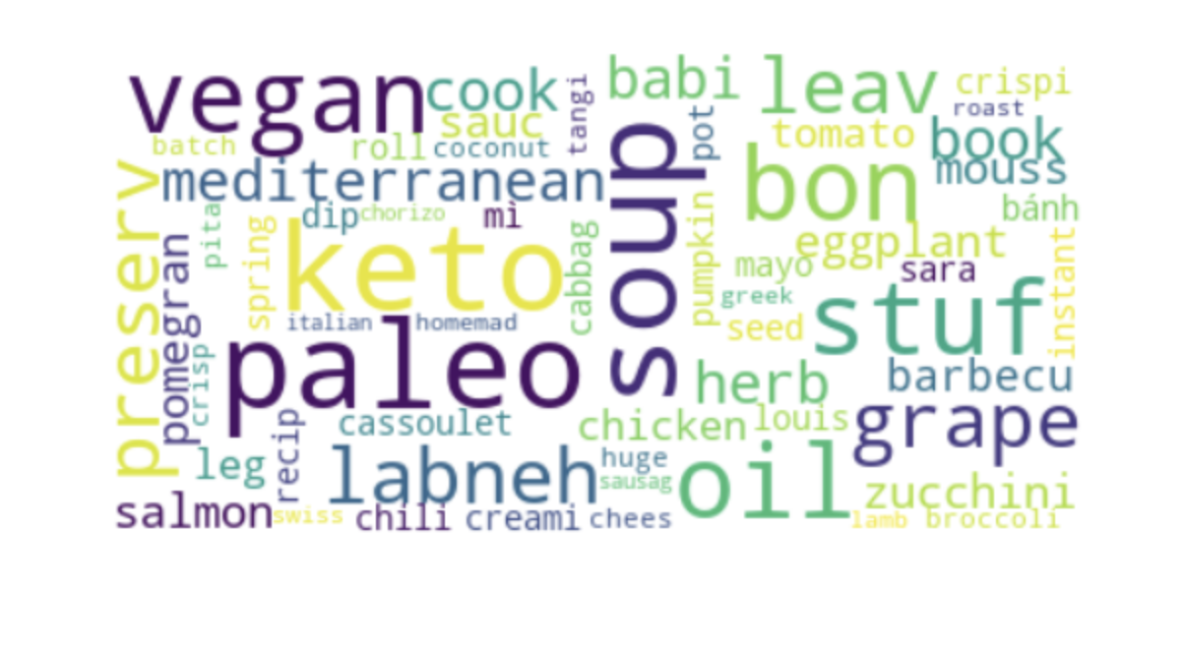The word cloud provides a visual representation of the most frequently mentioned words in the dataset related to recipes, diet types, and cuisine types. Here are some conclusions we can draw:

1. **Popular Diet Types**:
   * **Keto** and **Paleo** diets are prominently featured, indicating a significant number of recipes categorized under these diet types.
   * **Vegan** and **Mediterranean** diets are also frequently mentioned, suggesting they are popular among the recipe data.
2. **Common Ingredients and Food Terms**:
   * **Soup**, **oil**, **stuff**, and **preserve** are some of the most frequently mentioned terms, indicating common ingredients or preparation methods.
   * Other frequently mentioned ingredients include **grape**, **herb**, **eggplant**, **zucchini**, and **salmon**. These ingredients might be commonly used across various recipes.

Top 3 Highest Fat Recipe:

**Conclusions:**

* **Paleo and Keto Diets**: Feature prominently in high-fat recipes, aligning with their dietary principles of higher fat intake.
* **Vegan Diet**: Can also include high-fat recipes, mainly from plant-based sources like seeds and legumes.
* **Mediterranean Diet**: Incorporates healthy fats from sources like olive oil and fish, maintaining a balanced approach.
* **DASH Diet**: Even though it's focused on low-fat, heart-healthy recipes, there are still options with higher fat content, usually from healthy fats.

Top 3 Highest Protein Recipe:

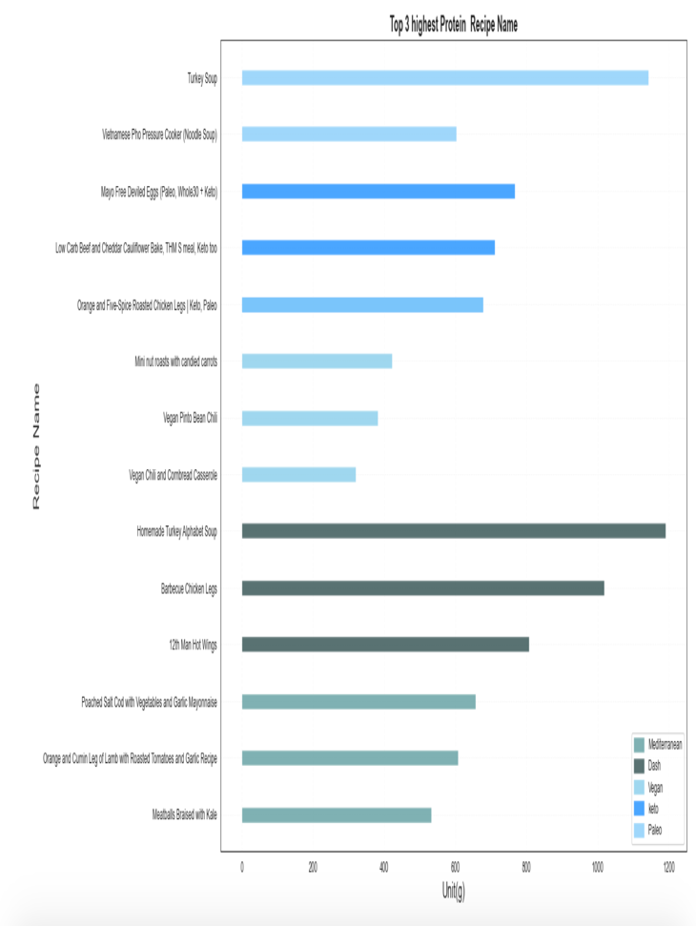

**Conclusion:**

The highest protein recipe is "Turkey Soup" under the Mediterranean diet. Recipes such as "Vietnamese Pho Pressure Cooker (Noodle Soup)" and "Mayo Free Devilled Eggs (Paleo, Whole30 + Keto)" are also high in protein but fall under the Keto and Paleo diets respectively.

**Recommendations:**

1. **For High-Protein Diet Seekers**:
   * Consider recipes such as "Vietnamese Pho Pressure Cooker (Noodle Soup)" and "Mayo Free Devilled Eggs." These diets often prioritize low-carb and high-protein meals, making them suitable for those looking to build muscle or lose weight.
2. **Balanced Diet Enthusiasts**:
   * While vegan options like "Vegan Pinto Bean Chili" and "Vegan Chili and Cornbread Casserole" have moderate protein levels.
3. **Health and Wellness**:
   * Mediterranean diet recipes are renowned for their heart-healthy benefits, thanks to the inclusion of healthy fats, lean proteins, and abundant vegetables. Recipes like "Turkey Soup" are beneficial for maintaining cardiovascular health.

Low-carb recipes from the Keto diet, such as "Orange and Five-Spice Roasted Chicken Legs," can help in managing blood sugar levels effectively

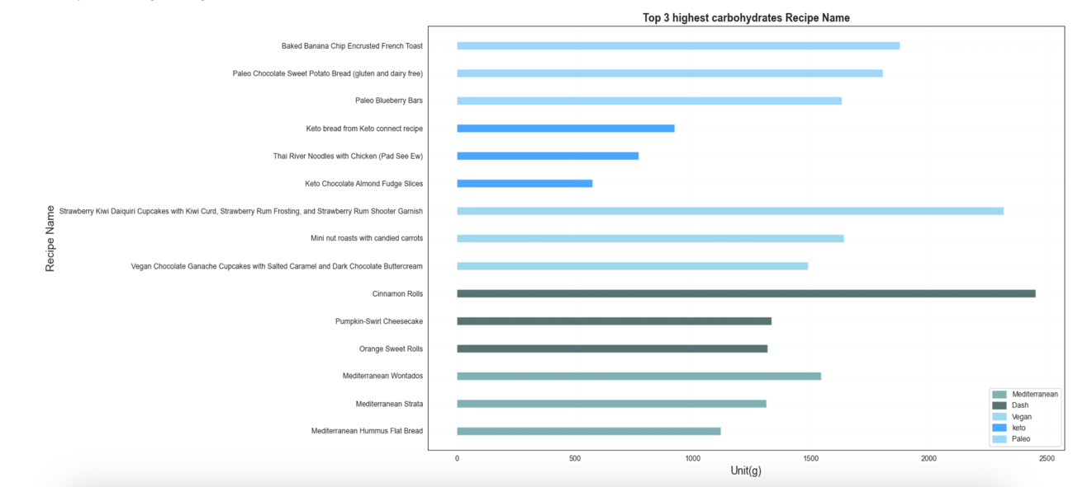Top 3 Highest carbohydrate Recipe:

**Observation:**

The highest carbohydrate content is in "Strawberry Kiwi Daiquiri Cupcakes with Kiwi Curd, Strawberry Rum Frosting, and Strawberry Rum Shooter Garnish" and "Baked Banana Chip Encrusted French Toast," both of which are under the Paleo and Keto diets respectively.

Vegan and Mediterranean diets also feature recipes with substantial carbohydrate content, such as "Vegan Chocolate Ganache Cupcakes with Salted Caramel and Dark Chocolate Buttercream" and "Cinnamon Rolls."

**Conclusion from Data Analysis and Market Segmentation:**

A balanced diet that aligns with individual health goals should focus on moderation, variety, and the right mix of macronutrients:

1. **Macronutrient Balance**:
   * **Protein**: Aim for 20-30% of daily calories, focusing on lean sources like poultry, fish, beans, and legumes.
   * **Carbohydrates**: Comprise 45-65% of daily intake, prioritizing complex carbs from whole grains, vegetables, and fruits.
   * **Fats**: Keep fats at 20-35% of daily calories, with an emphasis on healthy unsaturated fats from sources like olive oil, nuts, and avocados.
2. **Diet Type Considerations**:
   * **Dash and Mediterranean diets** are well-rounded and support heart health, making them excellent choices for overall well-being.
   * **Vegan diets** can be healthy but require careful planning to ensure adequate protein, Vitamin B12, iron, and omega-3 intake.
3. **Moderation and Variety**:
   * Avoid extreme diets that overly restrict or emphasize one nutrient, as this can lead to imbalances. A diverse diet incorporating foods from all groups supports long-term health.